# **Air Via Designed System**

|  |  |
| --- | --- |
|  | |
| **Document Intention:** | Report to Air Via on product design. |
| **Document Authors:** | Alfred Manville, Skyway Solutions |
| **Document Version Date-Stamp:** | 05/03/2023 |
| **Document Version:** | 1 |
| **Document Version History:** | |
| 1. Document created. | |

Table of Contents

**Air Via Designed System** 1

**Introduction** 3

**Requirements Specification** 4

**Current System Description** 4

**Use Case Analysis Diagram** 5

**Key Use Cases** 6

**Use Case ID: 1** 6

**Use Case ID: 2** 7

**Use Case ID: 3** 9

**Use Case ID: 4** 10

**Use Case ID: 5** 11

**Use Case ID: 6** 11

**ID: TM01** 13

**ID: TM02** 14

**ID: TM03** 15

**Use Case Prioritization List** 18

**System Design** 21

**Class Design Diagram** 22

**Class Design Diagram Split (1/2):** 23

**Class Design Diagram Split (2/2):** 24

**ER Diagram** 25

**Database Schema** 26

**GUI Designs** 31

**Administrator GUI** 31

**Office Manager GUI** 32

**Login GUI** 33

**Travel Advisor GUI** 35

**Review** 36

# **Introduction**

This document contains the design document of the system requested, due to communication issues via email we were unable to get some information about how the current system operated and how you wish the new system to operate. We hope that communication issues are resolved so clarifications can happen during project development. This document contains a description of the current system with its limitations, the use cases of the new system you have requested along with key use case specifications (9) and a priority of all specifications. The class design diagram is also contained with a mostly complete viewing of all designed classes showing how each component package of your new system will interface. There is an Entity Relationship (ER) diagram showing how your database will store the data from the software and schema to give you an example of how to operate it (Useful for the system administrator). Finally, we have some mock up GUIs and what actions my team expects them to have, these are subject to change of course as you only want the best software.

# **Requirements Specification**

This section contains the existing system description, use case analysis diagram, a set of 9 use case specifications and a priority listing of all use cases along with a justification of doing this.

## **Current System Description**

The existing software can accept blanks (Which are non-issued tickets) from an airline into the system. These blanks can then be sold by travel advisors which are assigned blanks by the office manager. These blanks can be different types (As represented by a 3-digit numeral code) defining what they can be used for (Journeys and the like via a coupon system not handled by sales). Blanks can be revoked if stolen, returned to the airline if unused and voided if a mistake is made when selling them. Travel Advisors can produce their individual sales reports for interline and domestic while office managers can produce reports for any travel advisor and global reports for interline and domestic sales. The system does not use a graphical interface at the moment (Terminal used) nor does it have adequate security so different roles can access functions they shouldn’t be able to. A limitation in the software requires manual coding of the currency exchange rate each time a sale is made in a different currency, which can lead to errors if the information is incorrect. If this occurs, the entire sale must be deleted and recreated, causing inconvenience. Furthermore, commission rates for tickets sold by travel agents are also hard-coded, adding to the limitations of the system. The system also struggles with concurrency control issues with the database, causing further complications in the smooth functioning of the system. The system lacks a discount system for valued customers and requires payment on the spot as late payments are not supported. The system also lacks the ability to perform accurate refunds as the current commission rate is not stored with the sale.

## **Use Case Analysis Diagram**

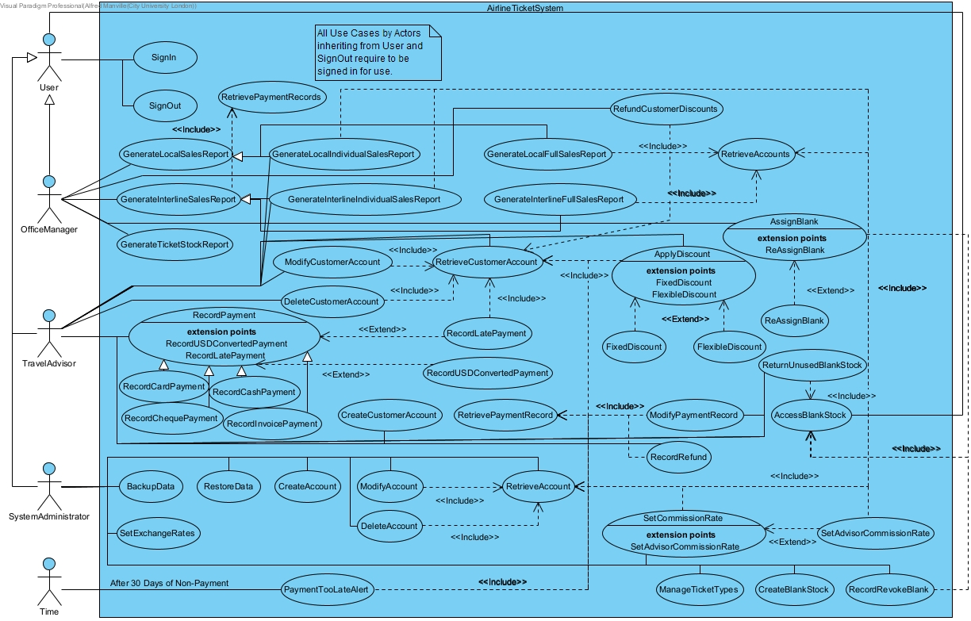

## **Key Use Cases**

|  |  |
| --- | --- |
| **Use Case ID: 1** | **Use Case:** SignIn |

|  |
| --- |
| **Brief Description:**  Signs the user in to access the rest of the application. |
| **Primary Actors:** User |
| **Secondary Actors:** None |
| **Preconditions:**   1. There is a connection to the database. |
| **Main Flow:**   1. The user is presented with the ability to enter a username and password. 2. The user enters a username and password. 3. The user presses the login button. 4. The user gets logged in. 5. The user gets stored as the logged in user. 6. The screen gets updated to the GUI for the role of the logged in user. |
| **Postconditions:**   1. The user has been logged in. 2. The screen has been updated to the GUI for the role of the logged in user. |
| **Alternative Flows:**   * LoginAttemptFailed * ConnectionUnavailable |

|  |  |
| --- | --- |
| **Use Case ID: 1** | **Use Case:** SignIn : LoginAttemptFailed |
| **Brief Description:**  The user specified does not exist or the password being incorrect will trigger this. | |
| **Primary Actors:** User | |
| **Secondary Actors:** None | |
| **Preconditions:**   1. The user may have entered their username and password. 2. The login button has been pressed. 3. The username and password have been checked. | |
| **Alternative Flow:**   1. This flow starts after step 4 of the main flow. 2. The system shows an error on screen for “Login Attempt Failed.”. 3. The main flow is aborted. | |
| **Postconditions:**  None. | |

|  |  |
| --- | --- |
| **Use Case ID: 1** | **Use Case:** SignIn : ConnectionUnavailable |
| **Brief Description:**  The database connection was unavailable for query. | |
| **Primary Actors:** User | |
| **Secondary Actors:** None | |
| **Preconditions:**   1. The user may have entered their username and password. 2. The login button has been pressed. 3. The database is no longer available for connection. | |
| **Alternative Flow:**   1. This flow starts after step 3 of the main flow. 2. The system shows an error on screen for “Database Unavailable.”. 3. The main flow is aborted. | |
| **Postconditions:**  None. | |

|  |  |
| --- | --- |
| **Use Case ID: 2** | **Use Case:** SignOut |
| **Brief Description:**  Signs the user out, back to the login screen. | |
| **Primary Actors:** User | |
| **Secondary Actors:** None | |
| **Preconditions:**   1. The user is logged in. 2. There is a connection to the database. 3. The user has pressed the sign out button. | |
| **Main Flow:**   1. The user has any uncommitted database information processed. 2. The screen switches to the login GUI. 3. The user is no longer stored as the logged in user. | |
| **Postconditions:**   1. The GUI screen is now the login GUI. 2. The user is no longer stored as the logged in user. | |
| **Alternative Flows:**   * ConnectionUnavailable | |

|  |  |
| --- | --- |
| **Use Case ID: 2** | **Use Case:** SignOut : ConnectionUnavailable |
| **Brief Description:**  The database connection was unavailable for storage. | |
| **Primary Actors:** User | |
| **Secondary Actors:** None | |
| **Preconditions:**   1. The sign out button was pressed. 2. The database is no longer available for connection. | |
| **Alternative Flow:**   1. This flow starts after step 1 of the main flow. 2. The system shows an error on screen for “Database Unavailable.”. 3. The main flow is aborted. | |
| **Postconditions:**  None. | |

|  |  |
| --- | --- |
| **Use Case ID: 2** | **Use Case:** CreateAccount |
| **Brief Description:**  Creates a new user account to access the system. | |
| **Primary Actors:** SystemAdministrator | |
| **Secondary Actors:** None | |
| **Preconditions:**   1. The user is logged in. 2. The user has pressed the create account button. | |
| **Main Flow:**   1. The user is shown an interface that allows them to enter all the personal information of the staff member, set the role of the staff member, their local currency, their password (With a confirm password box) and the email (Which acts as the username). 2. If the selected role is TravelAdvisor:    1. Allow for the commission percentage to be set. 3. Pressing the create button generates the account. 4. The add user interface is closed. | |
| **Postconditions:**   1. The GUI is closed. 2. The account is created. | |
| **Alternative Flows:**   * PasswordsNotMatching * Cancelled * ConnectionUnavailable | |

|  |  |
| --- | --- |
| **Use Case ID: 3** | **Use Case:** CreateAccount : PasswordsNotMatching |
| **Brief Description:**  The password and confirm password text boxes do not have matching contents. | |
| **Primary Actors: SystemAdministrator** | |
| **Secondary Actors:** None | |
| **Preconditions:**   1. The create account button was pressed. 2. The text in the password and confirm password textboxes do not match. | |
| **Alternative Flow:**   1. This flow starts after step 3 of the main flow. 2. The system shows an error on screen for “Passwords do not match.”. 3. The main flow is reset to step 2. | |
| **Postconditions:**   1. The main flow is now back to step 2. | |

|  |  |
| --- | --- |
| **Use Case ID: 3** | **Use Case:** CreateAccount : Cancelled |
| **Brief Description:**  The create account operation was cancelled. | |
| **Primary Actors: SystemAdministrator** | |
| **Secondary Actors:** None | |
| **Preconditions:**   1. The cancel button was pressed. | |
| **Alternative Flow:**   1. This flow starts after step 2 of the main flow. 2. The GUI is closed. 3. The main flow is aborted. | |
| **Postconditions:**   1. The GUI is closed. | |

|  |  |
| --- | --- |
| **Use Case ID: 3** | **Use Case:** CreateAccount : ConnectionUnavailable |
| **Brief Description:**  The database connection was unavailable for storage. | |
| **Primary Actors: SystemAdministrator** | |
| **Secondary Actors:** None | |
| **Preconditions:**   1. The create account button was pressed. 2. The database is no longer available for connection. | |
| **Alternative Flow:**   1. This flow starts after step 3 of the main flow. 2. The system shows an error on screen for “Database Unavailable.”. 3. The main flow is reset to step 2. | |
| **Postconditions:**   1. The main flow is now back to step 2. | |

|  |  |
| --- | --- |
| **Use Case ID: 4** | **Use Case:** RetrieveAccounts |
| **Brief Description:**  Retrieves all accounts from the database. | |
| **Primary Actors:** None | |
| **Secondary Actors:** None | |
| **Preconditions:**   1. The user is logged in. 2. There is a connection to the database. | |
| **Main Flow:**   1. The database is queried for accounts. 2. For each queried account:    1. Store the queried account as an account object in an array. | |
| **Postconditions:**   1. There is now an array storing account objects. | |
| **Alternative Flows:**   * ConnectionUnavailable | |

|  |  |
| --- | --- |
| **Use Case ID: 4** | **Use Case:** RetrieveAccounts: ConnectionUnavailable |
| **Brief Description:**  The database connection was unavailable for querying. | |
| **Primary Actors: SystemAdministrator** | |
| **Secondary Actors:** None | |
| **Preconditions:**   1. The database connection is now unavailable. | |
| **Alternative Flow:**   1. This flow starts after step 1 of the main flow. 2. An empty array is stored. 3. The main flow is aborted. | |
| **Postconditions:**   1. An empty array has been stored. | |

|  |  |
| --- | --- |
| **Use Case ID: 5** | **Use Case:** RetrieveAccount |
| **Brief Description:**  Retrieves an account from the account array. | |
| **Primary Actors:** None | |
| **Secondary Actors:** None | |
| **Preconditions:**   1. The user is logged in. 2. There is a connection to the database. 3. There is an account being searched for. | |
| **Main Flow:**   1. Include(RetrieveAccounts) 2. For each stored account in the array:    1. If the account is the one being searched for:       1. Return the stored account. 3. Return null | |
| **Postconditions:**   1. A value representing the stored account is returned. | |
| **Alternative Flows:**  None | |

|  |  |
| --- | --- |
| **Use Case ID: 6** | **Use Case:** ModifyAccount |
| **Brief Description:**  Modifies an existing user account. | |
| **Primary Actors:** SystemAdministrator | |
| **Secondary Actors:** None | |
| **Preconditions:**   1. The user is logged in. 2. The user has selected an account to modify. 3. The user has pressed the modify account button. | |
| **Main Flow:**   1. Include(RetrieveAccount) 2. The user is shown an interface that allows them to enter all the personal information of the staff member, set the role of the staff member, their local currency, their password (With a confirm password box). The username part is readonly showing the current username and so is the role, showing the current role. 3. If the selected role is TravelAdvisor:    1. Allow for the commission percentage to be set. 4. Pressing the update button updates the account. 5. The add user interface is closed. | |
| **Postconditions:**   1. The GUI is closed. 2. The account is updated. | |
| **Alternative Flows:**   * PasswordsNotMatching * Cancelled * ConnectionUnavailable | |

|  |  |
| --- | --- |
| **Use Case ID: 6** | **Use Case:** ModifyAccount : PasswordsNotMatching |
| **Brief Description:**  The password and confirm password text boxes do not have matching contents. | |
| **Primary Actors: SystemAdministrator** | |
| **Secondary Actors:** None | |
| **Preconditions:**   1. The create account button was pressed. 2. The text in the password and confirm password textboxes do not match. | |
| **Alternative Flow:**   1. This flow starts after step 4 of the main flow. 2. The system shows an error on screen for “Passwords do not match.”. 3. The main flow is reset to step 3. | |
| **Postconditions:**   1. The main flow is now back to step 3. | |

|  |  |
| --- | --- |
| **Use Case ID: 6** | **Use Case:** ModifyAccount : Cancelled |
| **Brief Description:**  The modify account operation was cancelled. | |
| **Primary Actors: SystemAdministrator** | |
| **Secondary Actors:** None | |
| **Preconditions:**   1. The cancel button was pressed. | |
| **Alternative Flow:**   1. This flow starts after step 3 of the main flow. 2. The GUI is closed. 3. The main flow is aborted. | |
| **Postconditions:**   1. The GUI is closed. | |

|  |  |
| --- | --- |
| **Use Case ID: 6** | **Use Case:** ModifyAccount : ConnectionUnavailable |
| **Brief Description:**  The database connection was unavailable for storage or querying. | |
| **Primary Actors: SystemAdministrator** | |
| **Secondary Actors:** None | |
| **Preconditions:**   1. The update account button was pressed. 2. The database is no longer available for connection. | |
| **Alternative Flow:**   1. This flow starts after steps 1 or 4 of the main flow. 2. The system shows an error on screen for “Database Unavailable.”. 3. The GUI is closed. 4. The main flow is aborted. | |
| **Postconditions:**   1. The GUI is closed. | |

|  |  |
| --- | --- |
| **ID: TM01** | **Use case:** Assign Blanks |
| **Brief description:**  This describes the process of assigning blanks to different travel advisors. | |
| **Primary actors:**  Office Manager | |
| **Secondary actors:**  None | |
| **Preconditions:**  The user is logged in and has access to the database.  The blanks have been identified. | |
| **Flow of events:**  The blank has been received.  Then the office manager assigns it to the travel advisor | |
| **Postconditions:**  Blank has been assigned | |
| **Alternative flow:**  connection to the database is lost | |

|  |
| --- |
| Alternative flow: TravelAdvisorMistake |
| ID: TM01.1 |
| **Brief description:**  If the travel advisor makes a mistake the blank becomes void |
| **Primary actors:** Travel advisor |
| **Secondary actors:** None |
| **Preconditions:** user has logged in and has access to the database, blank has been identified |
| **Alternative flow:**  1.Travel advisor has inputted incorrect data  The void has now been voided |
| **Postconditions: this blank can now be assigned to another user.** |

|  |  |
| --- | --- |
| **ID: TM02** | **Use case:** Generate Report |
| **Brief description:**  User wants to generate a sales report to view | |
| **Primary actors:**  Office Manager | |
| **Secondary actors:**  None | |
| **Preconditions:**  The user is logged in and has access to the database. | |
| **Flow of events:**  The relevant data is retrieved from the database.  This information is then generated into a report.  This report is then made accessible to the office manager. | |
| **Postconditions:**  none | |
| **Alternative flow:**  connection to the database is lost | |

|  |
| --- |
| Alternative flow: DatabaseConnectionLost |
| ID: TM02.1 |
| **Brief description:**  The connection to the database has been lost, therefore a report cannot be generated |
| **Primary actors:** Office Manager |
| **Secondary actors:** None |
| **Preconditions:** user has logged in but has lost connection to the database |
| **Alternative flow:**  the office manager can try and reconnect to the database to generate the report |
| **Postconditions:** a secure connection to the database has been made |

|  |  |
| --- | --- |
| **ID: TM03** | **Use case:** SetComissionRate |
| **Brief description:**  Set the commission rate of the ticket fare and the functioin to add and remove it | |
| **Primary actors:**  System administrator | |
| **Secondary actors:**  None | |
| **Preconditions:**  The system administrator is logged in and has access to the database.  System has triggered the set commission rate function. | |
| **Flow of events:**  The contracts are retrieved and then the rates are checked which were agreed upon in the contracts.  This number is then put as the commission rate depending on what type of ticket it is | |
| **Postconditions:**  The new commission rate for this type of ticket is set and updated to the database | |

|  |  |
| --- | --- |
| ID: TM03 | **Use case:** Record Payment |
| **Brief description:**  Records the payments on the system | |
| **Primary actors: travel advisor** | |
| **Secondary actors: NONE** | |
| **Preconditions: system is logged in by user and travel agent 2. A payment must be made to record the payment.** | |
| **Flow of events: travel advisor,**  **record payment,**  **record either cash or card payment** | |
| **Postconditions:**  Payment is logged on the system | |

|  |  |
| --- | --- |
| ID: TM03 | **Use case:** Payment Too Late Alert |
| **Brief description: it indicates to the system whether or not the payments on the account is late or not** | |
| **Primary actors: Time, user, office manager** | |
| **Secondary actors: NONE** | |
| **Preconditions: payment wasn’t paid in 30 days** | |
| **Flow of events:**  Time (30 Days elapse),  Payment too late,   retrieve customer account.  Send indication if customer has late payments. | |
| **Postconditions:**  Indication sent to the user and office manager | |

|  |  |
| --- | --- |
| ID: TM03 | **Use case:** Sign in |
| **Brief description:**  Allows users to sign into the airline ticket system | |
| **Primary actors:  User** | |
| **Secondary actors:**  Database | |
| **Preconditions: user needs to enter username and password** | |
| **Flow of events:**  User,  Sign in,  Sign out, | |
| **Postconditions:**  User needs to be signed in to sign out of the system | |

|  |  |
| --- | --- |
| ID: TM03 | **Use case:** Record USD Converted Payment |
| **Brief description:**  Records all payments on the system in the USD currency so that the payment can be managed, and rough profits can be calculated accordingly. | |
| **Primary actors: travel advisors** | |
| **Secondary actors:**  None | |
| **Preconditions:**  Payment needs to be made,  Transaction needs to be converted in usdt | |
| **Flow of events:**  Travel advisor,  Record payment,  Record USD converted payment. | |
| **Postconditions:**  The payment is recorded and put in the database when it is converted. | |

|  |  |
| --- | --- |
| ID: TM03 | **Use case:** Retrieve Accounts |
| **Brief description: retrieves the account so the office manager can manage the account.** | |
| **Primary actors: Office manager** | |
| **Secondary actors: None** | |
| **Preconditions:**  Office manager requests for account retrieval,  The user had a not paid in time notification which automatically retrieves the user’s account. | |
| **Flow of events:**  Office manager,  Retrieve accounts,  Not paid in time,  Retrieve accounts,  Generate report,  Retrieve accounts | |
| **Postconditions:**  **Account retrieval gets sent to office manager and then back to the database.** | |

## **Use Case Prioritization List**

In any case, the justification of the order just requires a checking of the requires column (Where a use case requires another one to be complete to actually be implemented, also if the functionality that creates the data does not exist, it must exist before anything to retrieve this data can be used).

|  |  |  |  |
| --- | --- | --- | --- |
| **Priority** | **Use Case** | **Priority Justification** | **Requires** |
| 1 | SignIn | Signing in is one of the main requirements to secure the product and verify the user role. |  |
| 2 | SignOut | Signing out is required to allow another user to access the product. |  |
| 3 | CreateAccount | Creating an account via the system administrator is required to secure the product for different users with roles that can then access the product separately. | 1 |
| 4 | RetrieveAccounts | Retrieving accounts is used for generating reports, listing accounts, setting the commission rates (A key feature), modifying and deleting an account. | 1 |
| 5 | RetrieveAccount | Retrieves a single account, RetrieveAccounts is included by it. | 1, 4 |
| 6 | ModifyAccount | Allows for the account to have its personal information, password and role modified without deleting and recreating. | 5 |
| 7 | DeleteAccount | Allows for the account of a user that no longer works there to have their access removed. | 5 |
| 8 | CreateBlankStock | Allows for the blanks from the airline to be inputted into the system which is a key requirement for selling them. | 1 |
| 9 | AccessBlankStock | Required to access the stock of blanks in the database. | 8 |
| 10 | RecordRevokeBlank | Allows for blanks that have been stolen to be revoked in-order to stop them being sold (or used) by the system. | 9 |
| 11 | SetExchangeRates | Allows for the currency exchange from USD to different currencies to be stored for calculating the prices of a sale. | 1 |
| 12 | SetCommissionRate | Allows for the commission rate of accounts to be set which is a key requirement. | 4 |
| 13 | SetAdvisorCommissionRate | Allows for a single advisor to have their commission rate set requiring SetCommissionRate as its parent. | 12 |
| 14 | ManageTicketTypes | Allows for the list of pre-defined ticket types to be managed. | 1 |
| 15 | BackupData | Allows for data from the database to be backed up to a file, a key feature. | 1 |
| 16 | RestoreData | Allows data from the database to be loaded from a BackupData produced file. | 1 |
| 17 | CreateCustomerAccount | Allows for the customer to have an account with their personal information and discount information. | 1 |
| 18 | RetrieveCustomerAccount | Allows for a customer account to be Modified, Deleted, have a discount processed or late payments authorized, a key feature. | 1 |
| 19 | ModifyCustomerAccount | Allows for the customer account to have personal information changed, requires needing to be retrieved. | 18 |
| 20 | DeleteCustomerAccount | Allows for a customer that no longer exists to be deleted, requires needing to be retrieved. | 18 |
| 21 | ApplyDiscount | Allows for a customer to have a discount, requires the ability to retrieve a customer account. | 18 |
| 22 | FixedDiscount | Allows for a customer to have a fixed discount, extends ApplyDiscount. | 21 |
| 23 | FlexibleDiscount | Allows for a customer to have a discount based on the number of products they have purchased, extends ApplyDiscount. | 21 |
| 24 | RecordPayment | Allows for a payment to be recorded, requires the customer account system to exist. | 1 |
| 25 | RecordCardPayment | Allows for a card payment, inherits RecordPayment. | 24 |
| 26 | RecordCashPayment | Allows for cash payment, inherits RecordPayment. | 24 |
| 27 | RecordChequePayment | Allows for a cheque payment, inherits RecordPayment. | 24 |
| 28 | RecordInvoicePayment | Allows for an invoice payment, inherits RecordPayment. | 24 |
| 29 | RecordLatePayment | This processes late payments, extends RecordPayment. | 18, 24 |
| 30 | RecordUSDConvertedPayment | This converts local to USD for payments, extends RecordPayment. | 24 |
| 31 | RetrievePaymentRecord | Allows for payment records to be retrieved for modification and refunding. | 24 |
| 32 | ModifyPaymentRecord | Allows for payment records to be modified, a key feature, requires the ability to retrieve the record. | 31 |
| 33 | RecordRefund | Allows for a payment to be refunded which requires the ability to retrieve the payment record. | 31 |
| 34 | ReturnUnusedBlankStock | Allows for the unused blanks to be marked as returned, required feature. Requires actual blanks in the system. | 1 |
| 35 | AssignBlank | Allows for blanks to be assigned to an advisor, required feature. Requires actual blanks in the system. | 1 |
| 36 | ReAssignBlank | Allows for blanks to be re-assigned to an advisor, requires the ability to assign blanks. | 35 |
| 37 | RetrievePaymentRecords | Retrieves all payment records for reports. This requires something to actually create payment records. | 1 |
| 38 | GenerateTicketStockReport | Allows the generation of the ticket stock report, requires something to add blanks. | 9 |
| 39 | GenerateLocalSalesReport | Allows the generation of domestic sales reports using retrieved payment records. | 37 |
| 40 | GenerateInterlineSalesReport | Allows the generation of interline sales reports using the retrieved payment records. | 37 |
| 41 | GenerateLocalIndividualSalesReport | Allows the generation of staff specific domestic sales reports, everything else is required. | 5, 39 |
| 42 | GenerateInterlineIndividualSalesReport | Allows the generation of staff specific interline sales reports, everything else is required. | 5, 40 |
| 43 | GenerateLocalFullSalesReport | Allows the generation of domestic sales for all advisors, required but everything else is required. | 39 |
| 44 | GenerateInterlineFullSalesReport | Allows the generation of interline sales for all advisors, required but everything else is required. | 40 |
| 45 | RefundCustomerDiscounts | Allows for customers with cumulative discounts to be refunded, not as important as customers could just pay less on purchase. | 18 |
| 46 | PaymentTooLateAlert | Alerts to payments made after 30 days of non-payment, least needed of the requirements. | 18, ~~1~~ |

# **System Design**

This section contains the class design diagram, entity relationship (ER) diagram and SQL schema (For your system administrator and database) and the GUI plan (For critiquing). These images are large of course so they are on A3 pages (And you may need a magnifying glass, we sincerely apologies for this). The class design diagram is also pictured twice, once in full and then split into two (Print and stitch together to get these 2 pages as full).

## **Class Design Diagram**

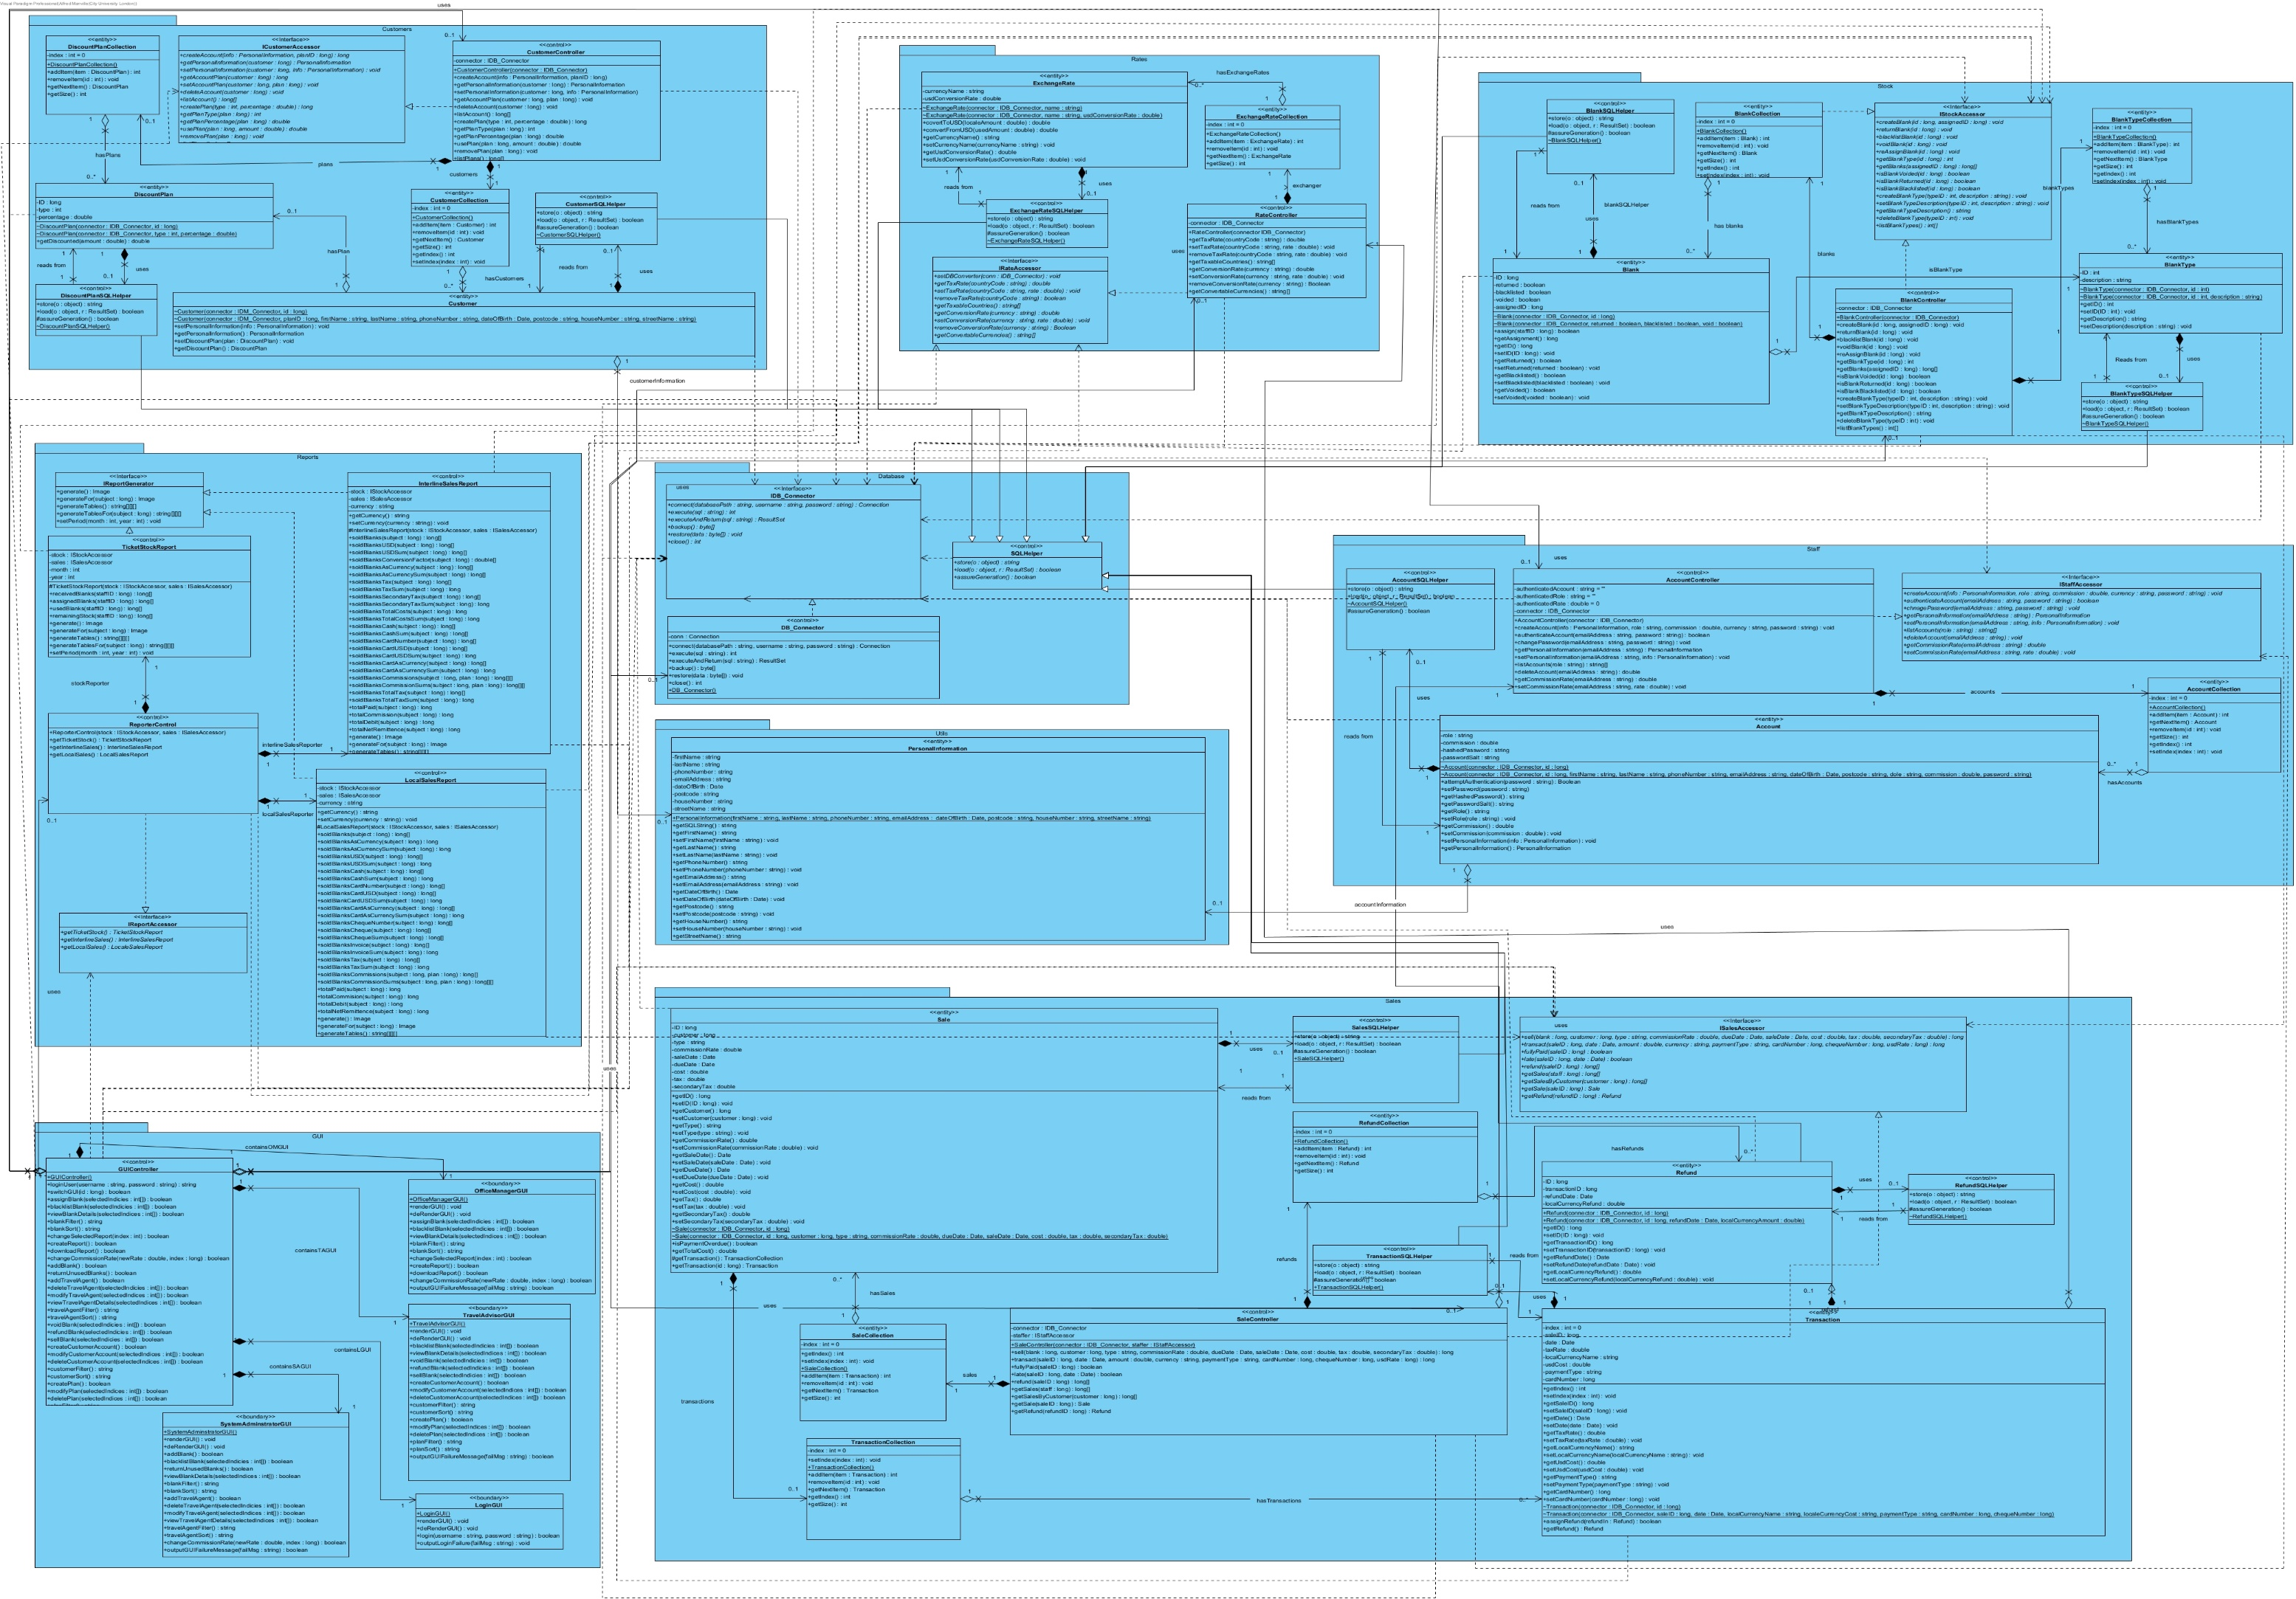

## **Class Design Diagram Split (1/2):**

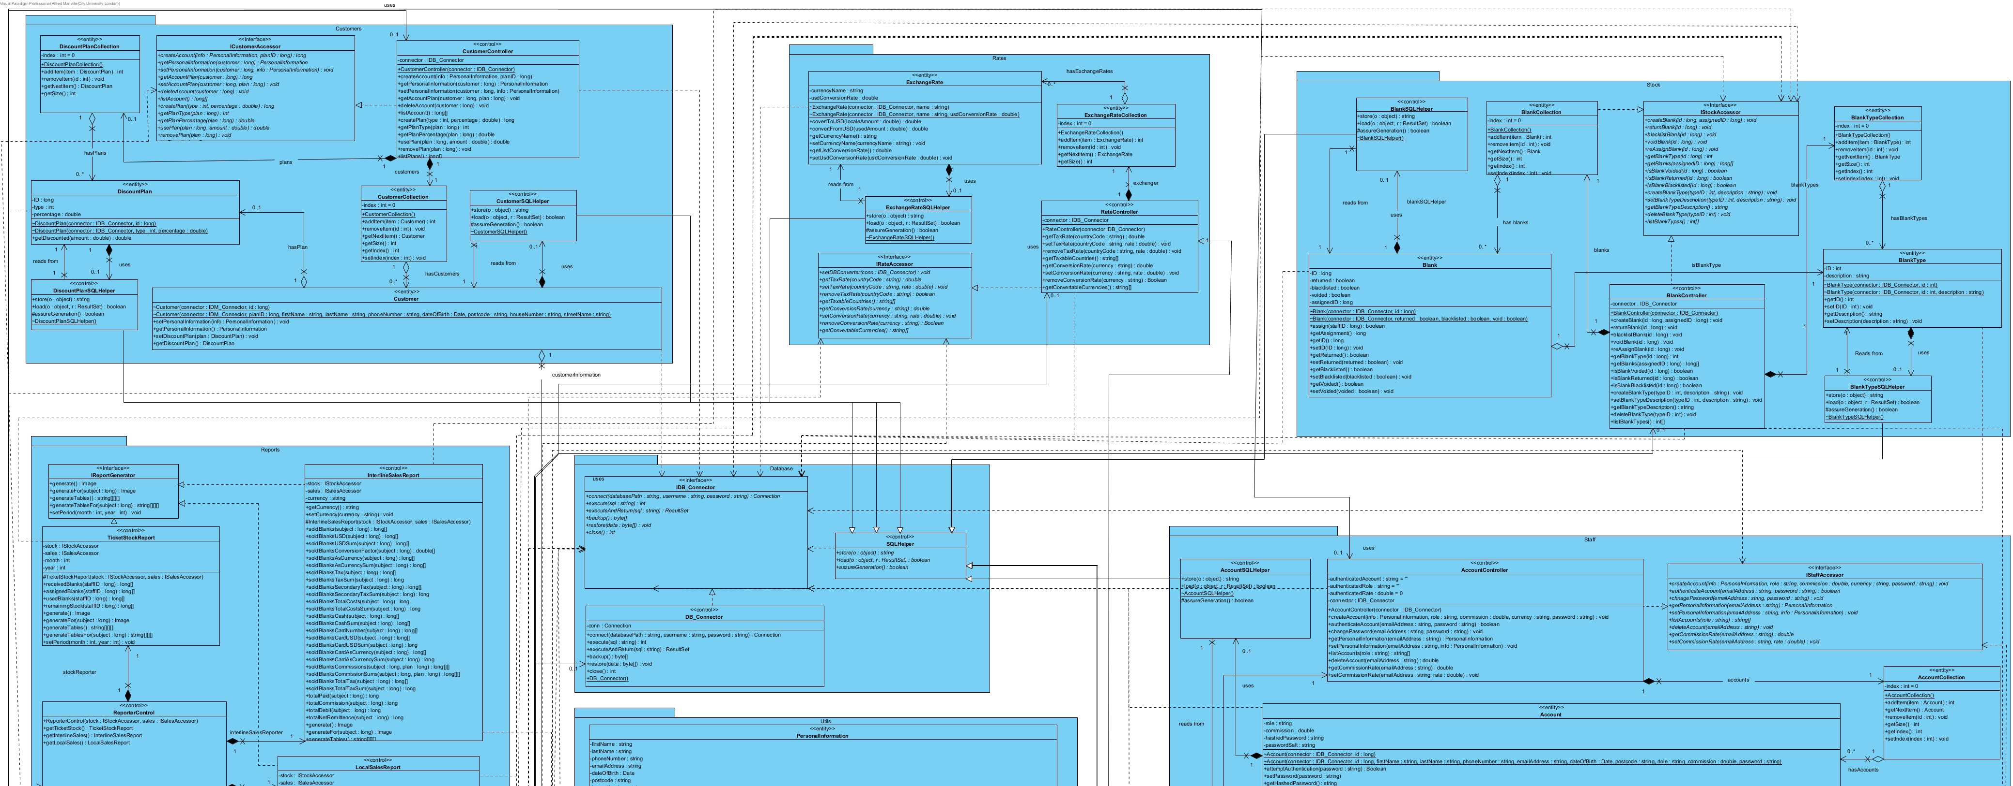

## **Class Design Diagram Split (2/2):**

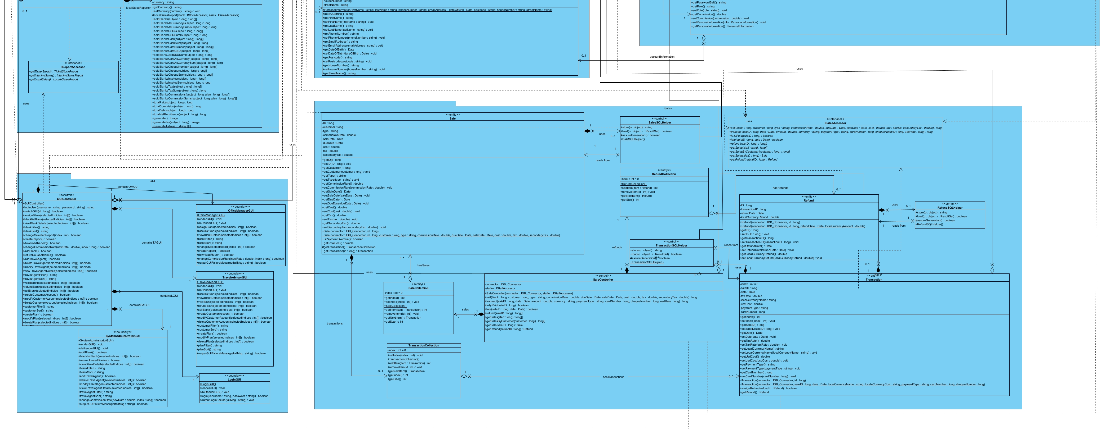

## **ER Diagram**

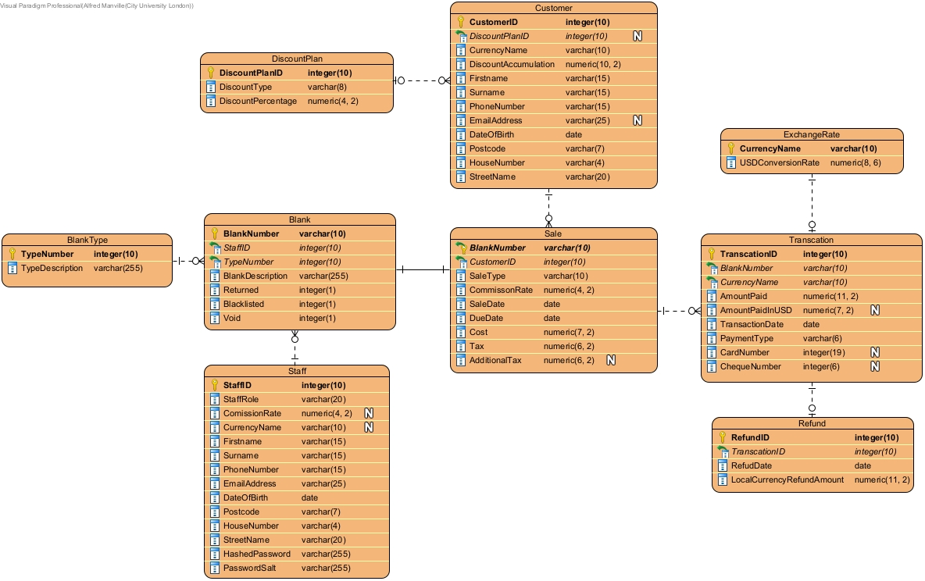

## **Database Schema**

/* Complete set of DDL statements (CREATE TABLE statements) */

CREATE TABLE Staff (

StaffID int(10) NOT NULL AUTO_INCREMENT,

StaffRole varchar(20) NOT NULL,

ComissionRate decimal(4, 2),

CurrencyName varchar(10),

Firstname varchar(15) NOT NULL,

Surname varchar(15) NOT NULL,

PhoneNumber varchar(15) NOT NULL,

EmailAddress varchar(25) NOT NULL,

DateOfBirth date NOT NULL,

Postcode varchar(7) NOT NULL,

HouseNumber varchar(4) NOT NULL,

StreetName varchar(20) NOT NULL,

HashedPassword varchar(255) NOT NULL,

PasswordSalt varchar(255) NOT NULL,

PRIMARY KEY (StaffID)

);

CREATE TABLE BlankType (

TypeNumber int(10) NOT NULL,

TypeDescription varchar(255) NOT NULL,

PRIMARY KEY (TypeNumber)

);

CREATE TABLE Blank (

BlankNumber varchar(10) NOT NULL,

StaffID int(10) NOT NULL,

BlankDescription varchar(255) NOT NULL,

Returned int(1) NOT NULL,

Blacklisted int(1) NOT NULL,

Void int(1) NOT NULL,

TypeNumber int(10) NOT NULL,

PRIMARY KEY (TypeNumber),

FOREIGN KEY (StaffID) REFERENCES Staff(StaffID),

FOREIGN KEY (TypeNumber) REFERENCES BlankType(TypeNumber)

);

CREATE TABLE DiscountPlan (

DiscountPlanID int(10) NOT NULL AUTO_INCREMENT,

DiscountType varchar(8) NOT NULL,

DiscountPercentage decimal(4, 2) NOT NULL,

PRIMARY KEY (DiscountPlanID)

);

CREATE TABLE Customer (

CustomerID int(10) NOT NULL AUTO_INCREMENT,

DiscountPlanID int(10),

CurrencyName varchar(10) NOT NULL,

DiscountAccumulation decimal(10, 2) NOT NULL,

Firstname varchar(15) NOT NULL,

Surname varchar(15) NOT NULL,

PhoneNumber varchar(15) NOT NULL,

EmailAddress varchar(25),

DateOfBirth date NOT NULL,

Postcode varchar(7) NOT NULL,

HouseNumber varchar(4) NOT NULL,

StreetName varchar(20) NOT NULL,

PRIMARY KEY (CustomerID),

FOREIGN KEY (DiscountPlanID) REFERENCES DiscountPlan(DiscountPlanID)

);

CREATE TABLE Sale (

BlankNumber varchar(10) NOT NULL,

CustomerID int(10) NOT NULL,

SaleType varchar(10) NOT NULL,

CommissonRate decimal(4, 2) NOT NULL,

SaleDate date NOT NULL,

DueDate date NOT NULL,

Cost decimal(7, 2) NOT NULL,

Tax decimal(6, 2) NOT NULL,

AdditionalTax decimal(6, 2),

PRIMARY KEY (BlankNumber),

FOREIGN KEY (BlankNumber) REFERENCES Blank(BlankNumber),

FOREIGN KEY (CustomerID) REFERENCES Customer(CustomerID)

);

CREATE TABLE ExchangeRate (

CurrencyName varchar(10) NOT NULL,

USDConversionRate decimal(8, 6) NOT NULL,

PRIMARY KEY (CurrencyName)

);

CREATE TABLE Transcation (

TranscationID int(10) NOT NULL AUTO_INCREMENT,

BlankNumber varchar(10) NOT NULL,

CurrencyName varchar(10) NOT NULL,

AmountPaid decimal(11, 2) NOT NULL,

AmountPaidInUSD decimal(7, 2),

TransactionDate date NOT NULL,

PaymentType varchar(6) NOT NULL,

CardNumber int(19),

ChequeNumber int(6),

PRIMARY KEY (TranscationID),

FOREIGN KEY (BlankNumber) REFERENCES Sale(BlankNumber),

FOREIGN KEY (CurrencyName) REFERENCES ExchangeRate(CurrencyName)

);

CREATE TABLE Refund (

RefundID int(10) NOT NULL AUTO_INCREMENT,

TranscationID int(10) NOT NULL,

RefudDate date NOT NULL,

LocalCurrencyRefundAmount decimal(11, 2) NOT NULL,

PRIMARY KEY (RefundID),

FOREIGN KEY (TranscationID) REFERENCES Transcation(TranscationID)

);

/* 2 INSERT Statements */

INSERT INTO DiscountPlan VALUES (

DEFAULT,

"FIXED",

4.5

);

INSERT INTO Customer VALUES (

DEFAULT,

NULL,

"USD",

0,

"John",

"Doe",

"03648318215",

"JohnDoe@gmail.com",

"1965-05-12",

"RG3 2IK",

"233",

"Albert Road"

);

/* 2 UPDATE STATEMENTS */

UPDATE Customer

SET DiscountPlanID = 1

WHERE CustomerID = 1;

UPDATE Customer

SET Postcode = "PG4 4JK", HouseNumber = "5A", StreetName = "St. Johns Street"

WHERE CustomerID = 1;

/* 2 SELECT STATEMENTS */

SELECT Postcode, HouseNumber, StreetName

FROM Customer

WHERE DateOfBirth BETWEEN "1960-01-01" AND "1975-01-01";

SELECT COUNT(CustomerID) AS CustomersWithoutDiscountPlans

FROM Customer

WHERE DiscountPlanID IS NULL;

/* 2 DELETE STATEMENTS */

DELETE FROM Customer

WHERE CustomerID = 1;

DELETE FROM DiscountPlan

WHERE DiscountPlanID = 1;

/* SQL DML statements which are needed to create 2 non-trivial reports pertaining to the case-study */

/* Report 1 would be an Interline Sales Report an Report 2 would be a Domestic Sales Report */

INSERT INTO Staff VALUES (

DEFAULT,

"Travel Agent",

3.50,

"GDP",

"Percy",

"Benedict",

"0421135672",

"Percy.Benedict@ATS.com",

"1997-03-21",

"AA1 1BV",

"120A",

"St. Peter Street",

"!'@DHsdHFeS2!",

"DD$%FdsNC2!Dnd"

);

INSERT INTO BlankType VALUES

(444, "Two leg interline journey."),

(101, "Single leg domestic journey.");

INSERT INTO Blank VALUES

("4441003489", 1, "London to Seoul, Seoul to Manila", 0, 0, 0, 444),

("4444343235", 1, "London to Tokoyo, Tokoyo to Dublin", 0, 0, 0, 444),

("4401344491", 1, "London to Pairs, Paris to Lyon", 0, 0, 0, 444),

("1015003455", 1, "Liverpool to London", 0, 0, 0, 101),

("1014044431", 1, "Manchester to Luton", 0, 0, 0, 101);

INSERT INTO Sale VALUES

("4441023489", 1, "INTERLINE", 3.50, "2023-02-01", "2023-03-02", 1000.50, 200.00, 30.00),

("4444343235", 1, "INTERLINE", 3.50, "2023-02-04", "2023-03-05", 500.00, 100.00, 56.00),

("4401343491", 1, "INTERLINE", 3.50, "2023-02-05", "2023-03-06", 350.50, 50.00, 20.00),

("1015023455", 1, "DOMESTIC", 3.50, "2023-02-25", "2023-03-26", 187.40, 65.00, NULL),

("1014054431", 1, "DOMESTIC", 3.50, "2023-02-25", "2023-03-26", 187.00, 75.00, NULL);

INSERT INTO Transcation VALUES

(1, "4441023489", "USD", 1230.50, NULL, "2023-02-04", "CASH", NULL, NULL),

(2, "4444332435", "USD", 656.00, NULL, "2023-02-06", "CARD", 353435218, NULL),

(3, "4401344491", "USD", 420.00, NULL, "2023-02-08", "CASH", NULL, NULL),

(4, "1015002455", "GDP", 252.40, 302.52, "2023-02-25", "CASH", NULL, NULL),

(5, "1014045431", "GDP", 262.00, 314.04, "2023-02-27", "CHEQUE", NULL, 978424910);

## **GUI Designs**

### **Administrator GUI**

Links to: GUI::SystemAdministratorGUI

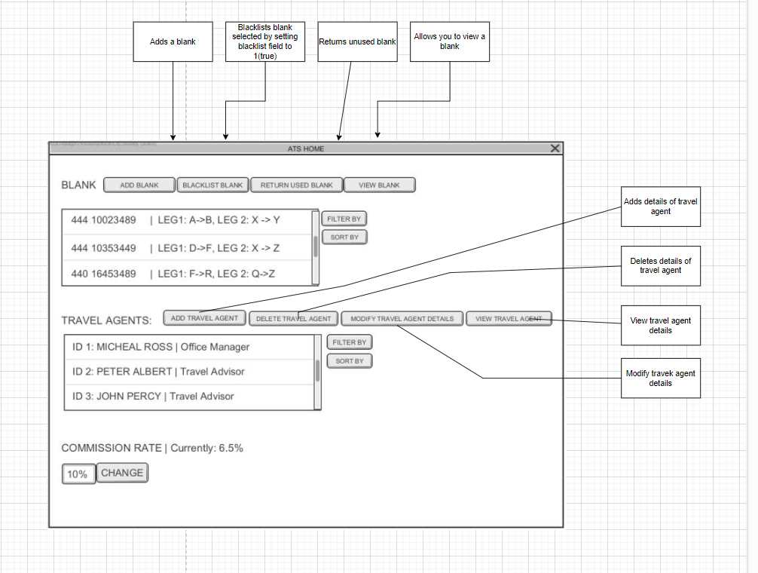

### **Office Manager GUI**

Links to: GUI::OfficeManagerGUI

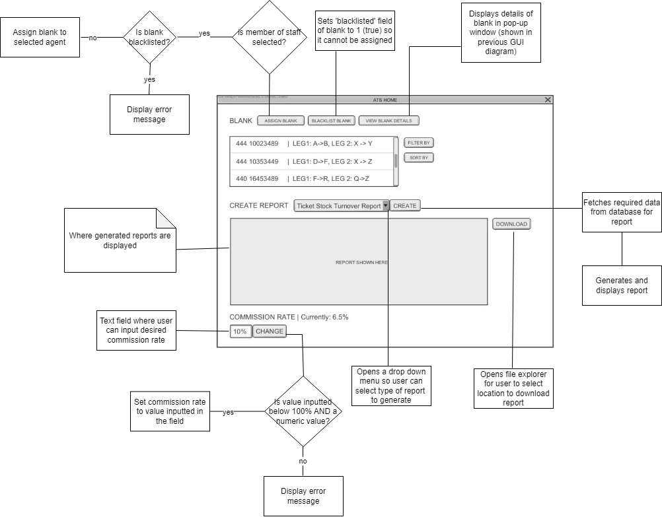

### **Login GUI**

Links to: GUI::LoginGUI

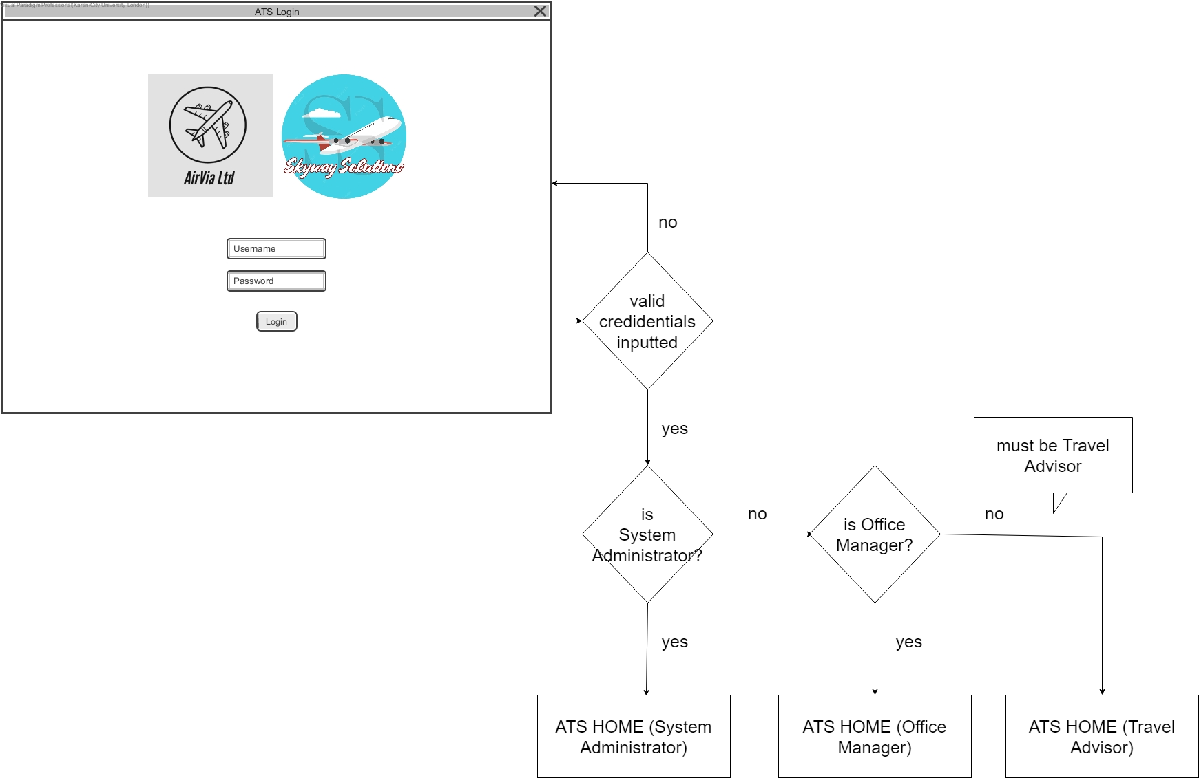

### **Travel Advisor GUI**

Links to: GUI::TravelAdvisorGUI

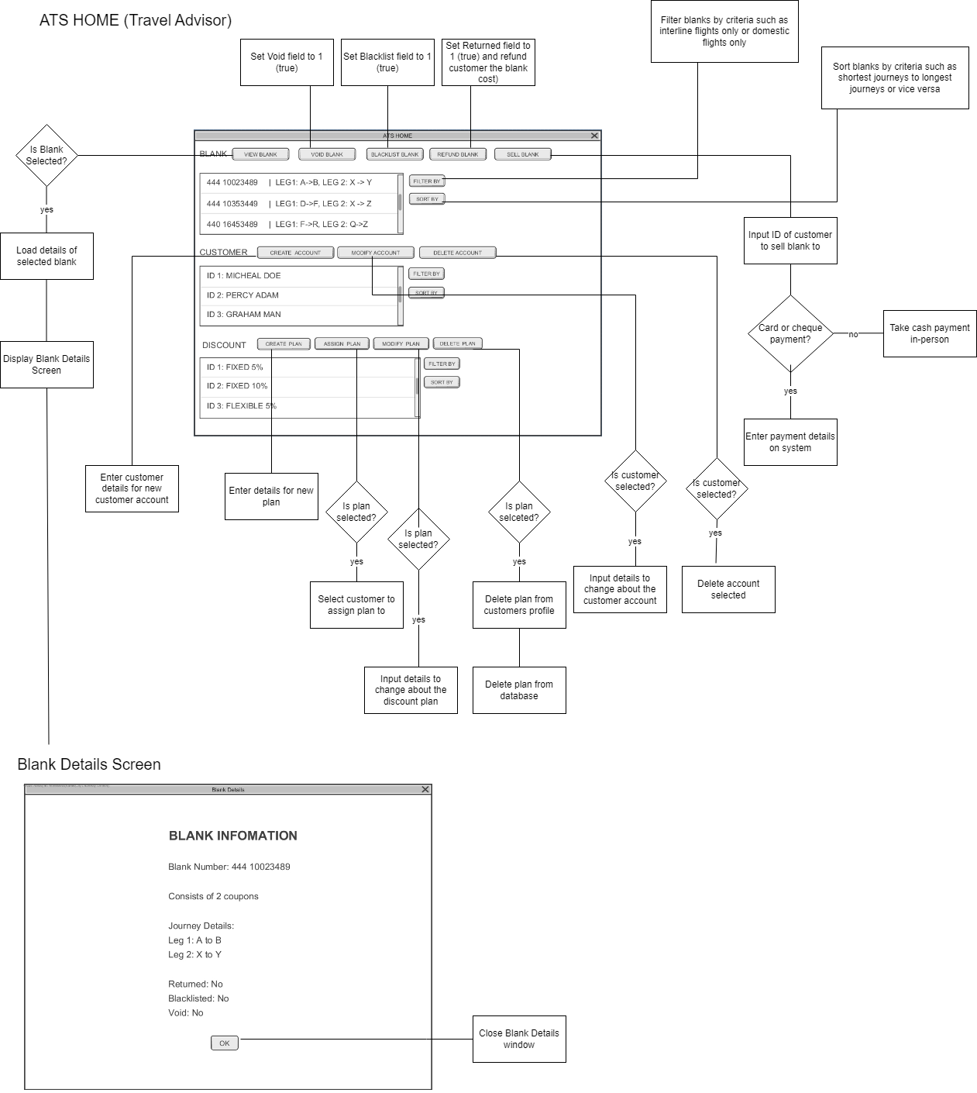

# **Review**

In conclusion, Skyway Solutions believes we have covered a good chunk of what was requested and we are lacking some information due to communications issues which we believe will be cleared up in time for product development. The project manager is making necessary arrangements for members to be briefed on skills they are missing so they can perform to their utmost ability to deliver the product on time.